DATABRICKCS

ALL YOU NEED TO KNOW ABOUT DATABRICKS

Autor : Coulibaly

Contents
INTRODUCTION 5
Data Bricks blocs to know 6
Magic command 7
Databriks Utilities 8
DATABRICKS FILE SYSTEM (DBFS) concept 8
CREATE SERVICE PRINCIPAL 8
Proces 8
Mount ADL to Databriks 8
SECRET MANAGEMENT in DBricks 9
Databricks for ETL processing 10
Process 10
Project Formule 1 13
Business Requirement 13
Architecture 13
Seach architecture 13
Final architecutre 14
Spark data Frame (API, Datasource API) capabilties 14
Input 14
Step 1 : Dowload files and load its into ADL 15
Step 2 : convert csv to Parquet file (with some transformation before) 15
Step 3 :Train data according to requirements 15
Requirment1 : read Data using dataFrame 15
Requirment2 : Check , create and adapt the schema (Simple and multi-line Json ) 15
Requirment3 : Need colums only , remane columns 16
Requirment4 : add audit colum 16
Requirment5 : Write data as Parquet file in ADL as parquet file 17
Requirment6 : Partition data based on year, month or Date 17
Requirment7 : Read and write Json files(without nested structure) as parquet 17
Requirment8 : Read and write Json files(with nested structure) as parquet 18
Requirment9 : Read and write Json files(with Other nested structure) as parquet 19
Requirment10 : Read and write multiple csv files(In a folder) as parquet 19
Child NoteBook : To make some codes reusable (Config) 20
Child NoteBook : Function in Notebook 20
• Replace in the other Notebook 21
Child NoteBook :Parameter in Notebook 21
Notebook workflow (Mater NoteBook) 21
DataBricks Job 21
FILTER in Notebook 21
JOIN IN Notebook 22
INNER JOIN 22
OUTER JOIN 22
SEMI JOIN 22
ANTI JOIN 22
ORDER BY 22
Create a Presentation Layer (for the joins) 22
AGGREGATION 23
Count 23
Sum 23
Group BY 23
Window function 23
SQL with SPARK 24
Create Local temp view and access with SQL 24
Create Global temp view and access with SQL 24
SQL DATABASE IN DATABRICKS 24
MANAGED TABLES 25
EXTERNAL TABLES 25
VIEWS 26
Temp view 26
Global view 26
Perment view 26
PROJECT including tables and views 27
VISUALIZATION 27
DASHBOARD 27
Encremental laod 28
DELTA LAKE 29
Create , Read and write Data into Delta Lake 29
Update Delete the Della Lake 29
Merge and upsert 30
History , Time Travel , Vacuum 30
Transaction log 31
Convert Parquet to Delta lake and back to Parquet file 31
EXERCICES USING DELTA TABALE 31
DATA FACTORY 31
Connect Power BI to DataBricks 31
Devops for the deployment 32
Some code 32
Full Config set up 33
Some error handeling 33

INTRODUCTION
Databricks is a spark big data en multilanguage management flatform where you ingest , transform, load you data files , table or deta lake . In a Databricks workspace you can create Noetbooks , clusters (to be abale to run these Nb) an job that will automacally run all the process using scheduling.
For Data Engineers Databriks is an ETL tool where you can apply the folowings :
- Project folder Folders ( Ex :Premier League) that will contain de following folders:
  - Set up folder contains notebooks for
    - Info on storage , service principal, general config with keyVault, mount ADL folders to Adb (Setion 6 . 26, 27, 29)
  - Ingestion folder
    - Read data from raw , Remove and rename, add audit columns , use schema
    - write data as parquet , csv or Delta lake to processed layer
  - Transformation folder
From the processed layer ,Apply join, look up to the files to built Presentation files required by the business and write incrementally , with partition this new dataset as Parquet, csv, of Delta Lake to the Presentation Layer
  - Function folder
To put all repetitive action and call its in other notebooks
  - Master notebook to run all the notebooks
- Use python or sql as default language , and from one another use a Magic command
- Create Database and table(Managed and external ) , views (Global , temp)
- Create Clusters where all you notebooks will run
- Create Job to plan the execution
- Run the Dbricks wp via ADF
Delta Lake is a data lake with ACID transaction support :
A: Atomicity this is the all or nothing principal , When One action in an operation fails will rollback all the operation (That makes sure that copy, changes into delta lake are securely execute this zero risk of missing data)
C: Consistent This approach will ensure the source and target are always aligned
I: Isolation Different commitments can be done at same time without blocking each other’s using snapshot of Transaction Logs that contains all currents info a Delta Lake files or table.
D:Duration When a transition is committed in Delta Lake it’s directly stores into a Disk and persist there even if the system fails;

Delta Lake file (Delta) | Data Lake file (csv, json, parquet)
No risk missing data by loading | risk missing data by loading
History management (Versions) | No history
Transaction log | No Transaction Log
Roll back by issue | No roll back bij issue
GDPR role management (Remove older data) | GDPR role not support

Data Bricks blocs to know
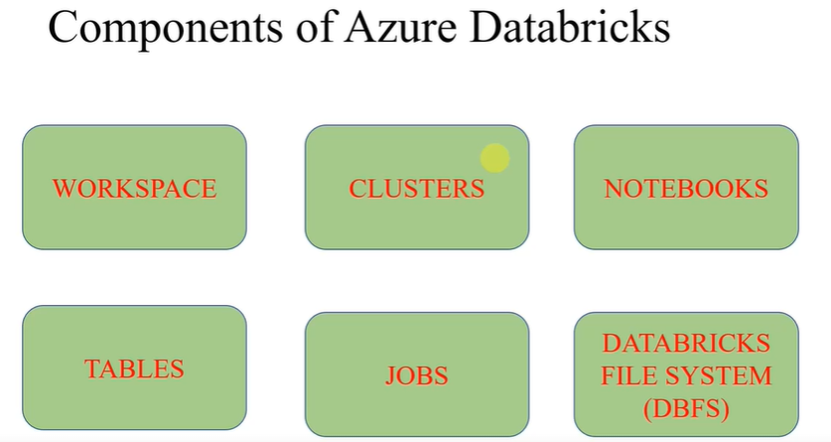

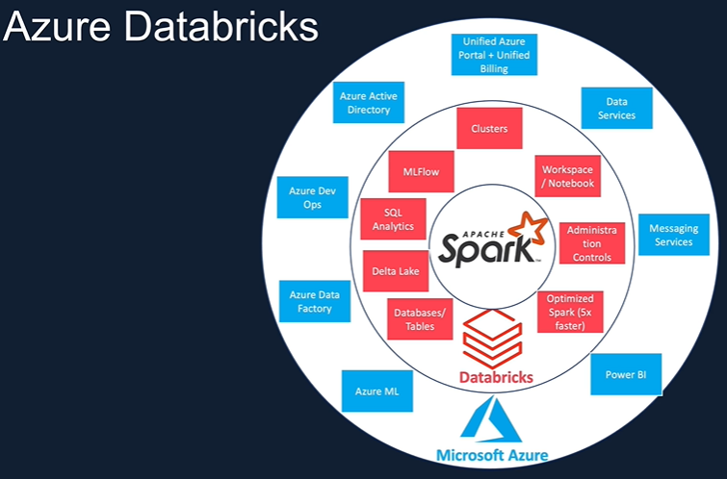
When you create a Databriks workspase , 3 others resourse will be automatically created for you (See below)
- Storage account
- Virtual network
- Virtual network group
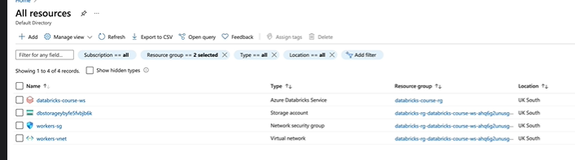

Magic command
Ref: Azure Databricks & Spark Core For Data Engineers(Python/SQL) (Section 5.20)

%Scala | swith to scala language
%SQL | swith to Sql language
%Python | swith to Phyton language
%md # # ** | For documentation structure in the code
%sh ps | To see running process
%fs ls | to check fils and folders an files we have (see below)

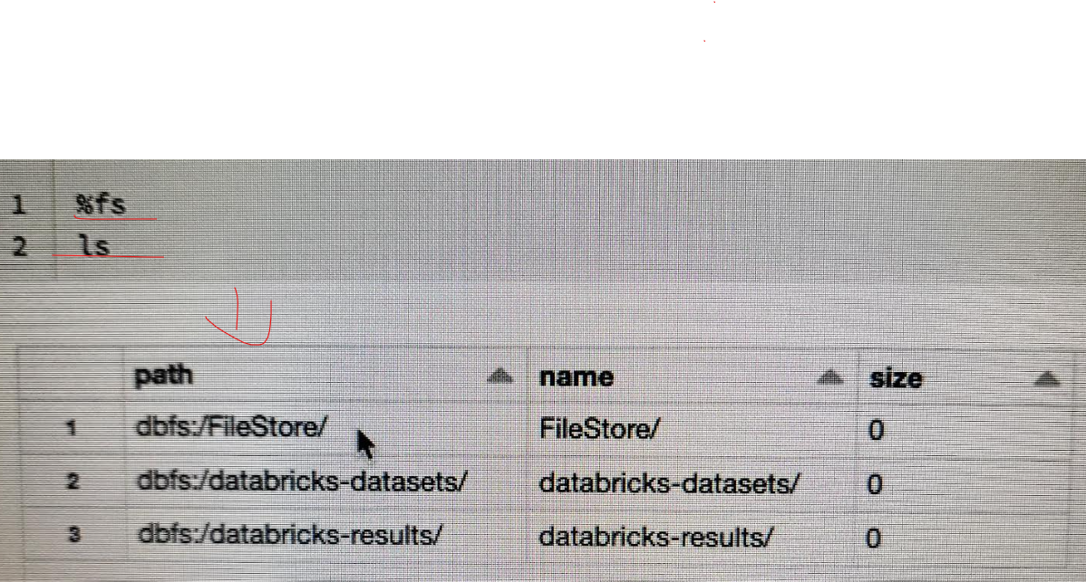
Exp : you can explore folders and file using
%fs ls - for folders %fs ls dbfs:/fileStore/
%fs Head --- to see a specific file %fs ls dbfs:/fileStore/file.csv

Databriks Utilities
Ref: Azure Databricks & Spark Core For Data Engineers(Python/SQL) (Section 5.21)

dbutils.fs.help() | To find all utilities regarding file system
dbutils.notebook.help() | To see what you can do here
dbutils.widgets.help() | To see what you can do here

DATABRICKS FILE SYSTEM (DBFS) concept
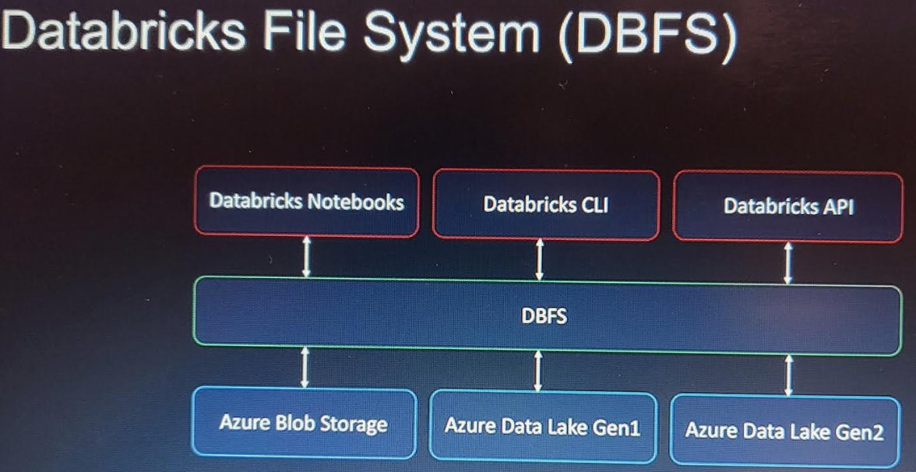

CREATE SERVICE PRINCIPAL

Proces
- To be created via Active directory using App registration.
The idea is to create an application (ex : databriksApp )that represent our databriks soltuion in active ditectory. This registration will produce 2 impotant information :
- Application ID
- Tenant ID
- Create also via AD a secret that will have a name and Value
- Add a Strage blob data Contributor role in ADL for the new service Principal (ex : databriksApp)

Mount ADL to Databriks
Azure Databricks & Spark Core For Data Engineers(Python/SQL) (Section 6.27)

To have access to Data Lake and put it into DBFS. The above info are crusial :
- Application ID
- Tenant ID
- secret

- Define info above as parameter (Using KeyVault best practiice )
- Use Config command
- Use mount script
- Explotre data in DBFS usin %fs ls ….
- Create function to move from foldr to another

SECRET MANAGEMENT in DBricks
Azure Databricks & Spark Core For Data Engineers(Python/SQL)
The best practice is to create the following
- KeyVault to strore the Secret of our Service Principal (databriksApp)
So 3 secret will be needed to store Application ID, Tenant ID , secret
- Databricks scope secret and connect it with KeyVault
So you needed 2 info from the KeyVault DSN Name = vault URI , ResourceID (See video Section 6.29)
- Then use this secret in Notebook, job on a more secure way (See video Section 6.30 )

Databricks for ETL processing

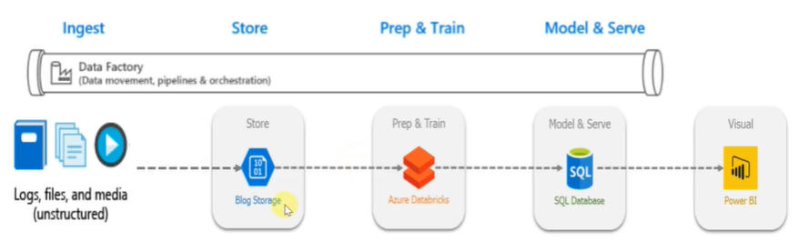

Process
- Load files into DATALAKE (ADL as Source) using Data factory
- Create a Azure SQL Server and Database (as Destination)
  - Important : Don’t forget the Firewall Setting of the SQL server
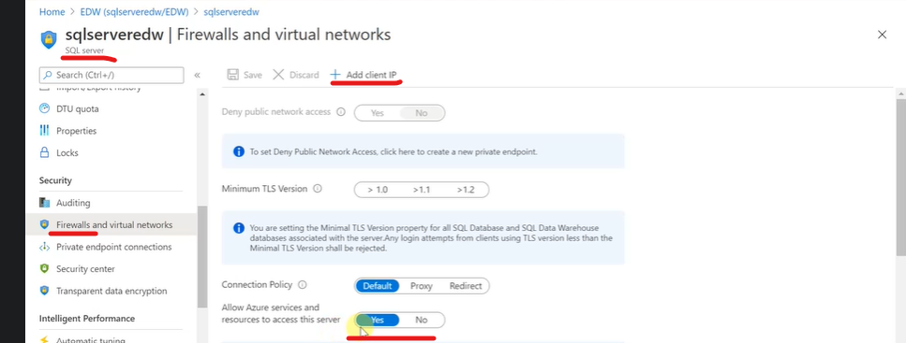
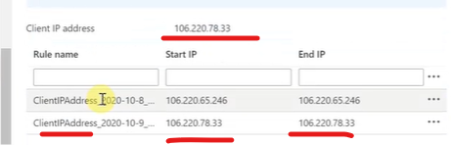

- Data Transformation (Databricks)
  - Mount ADL data on DataBriks files system for access to data
  - Create Global Tables in DataBricks that will contains Data Present in ADL
  - Now transformation can start (ETL)
  - Load data into Azure SQL DB (With incremental load)
- ETL with DataBricks

- Step 1 Umount and Mount Data
%scala
dbutils.fs.unmount("/mnt/Product_Category_Subcategory.csv")

dbutils.fs.mount(
source = "wasbs://ContenairName@DataLakeAccoutName.blob.core.windows.net/",
mountPoint = "/mnt/Product_Category_Subcategory.csv",
extraConfigs = Map("fs.azure.account.key. DataLakeAccoutName.blob.core.windows.net" -> "ENTER YOUR ACCESS KEY"))

NB: So you can mount all the data you need for the project.
Access Key
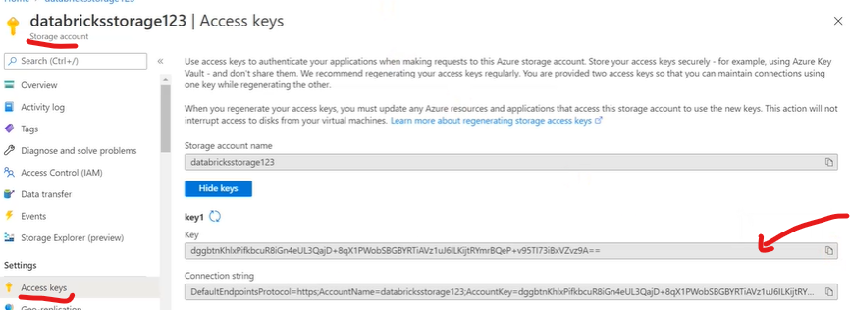

- Step 2 Create Global tables in Databriks
%sql
DROP TABLE IF EXISTS customer;
CREATE TABLE customer
USING csv
OPTIONS ( path "/mnt/customer-data.csv", header "true", mode "FAILFAST" );

---Test
Select * from customer
NB: This way you can create all Global Tables you need for the project
- Step 3 Transformation 1 = delete some unwanted data
NB: delete is not that easy instead you can move you wanted table to a new global table like below
%sql
drop table if exists customerdeleted;
create table customerdeleted
as
select * from customer where city_code like 'Boston'

- Step 4 Transformation 2 = Change data type load data µ
%scala

// Declare the values for your Azure SQL database

val jdbcUsername = "serveradmin"
val jdbcPassword = ""
val jdbcHostname = "sqlserveredw.database.windows.net"
val jdbcPort = 1433
val jdbcDatabase ="EDW"

// Create the JDBC URL without passing in the user and password parameters.
val jdbcUrl = s"jdbc:sqlserver://${jdbcHostname}:${jdbcPort};database=${jdbcDatabase}"
// Build a JDBC URL to hold the parameter/ secret

import java.util.Properties

val jdbc_url = s"jdbc:sqlserver://${jdbcHostname}:${jdbcPort};database=${jdbcDatabase};encrypt=true;trustServerCertificate=false;hostNameInCertificate=*.database.windows.net;loginTimeout=60;"
val connectionProperties = new Properties()
connectionProperties.put("user", s"${jdbcUsername}")
connectionProperties.put("password", s"${jdbcPassword}")

%scala

// Create dataframe of SQL table

val dimcustomer = spark.read.jdbc(jdbc_url, "dbo.dim_customer", connectionProperties)
dimcustomer.createOrReplaceTempView("Dim_Customer_local")

NB Local table (Dim_Customer_local) is only valid for a session and Global Table is permanent in de DataBricks
%scala

// Loading only not existing data in de Target Table

import org.apache.spark.sql.SaveMode

spark.sql("""select
cast(customerdeleted.customer_Id as int) customer_Id, // Conversion
customerdeleted.DOB,
customerdeleted.Gender,
customerdeleted.city_code,
customerdeleted.customer_name
from Dim_Customer_local right join customerdeleted
on Dim_Customer_local.customer_Id = customerdeleted.customer_id
where Dim_Customer_local.customer_Id is null""")
.write
.mode(SaveMode.Overwrite) // <--- Overwrite or Append the existing table
.jdbc(jdbcUrl, "Dim_Customer", connectionProperties)

- Create Job , configure the Cluster and Schedule to Run the notebook
See Udemy Video

Project Formule 1
PySpark code coll :https://spark.apache.org/docs/latest/api/python/reference/pyspark.sql/io.html

Business Requirement
- ADL
  - All input file ingest into ADL
  - Use the same schema during the load (Respecting data type and column name)
  - Addition of audit columns (Ingested date and source of data)
  - File store in Parquet format
  - Analysable via SQL sever
  - Incremental load

Architecture
Go to Azure Architecture center website to find out the most applicable achitechture to your project

Seach architecture
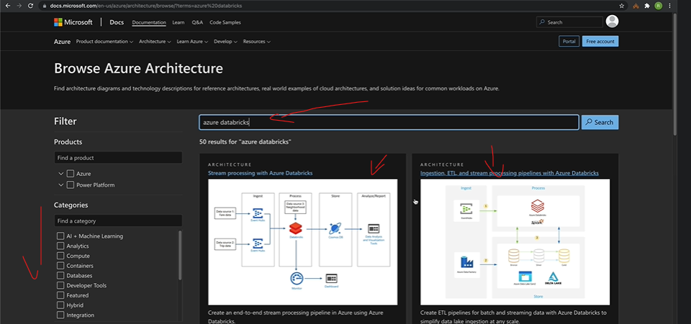

Final architecutre
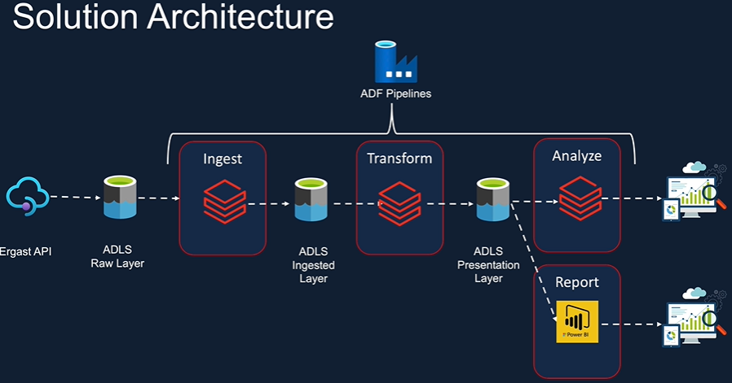

Spark data Frame (API, Datasource API) capabilties
- Read (to read from all kind of data source csv,parquet,json,JDBC …)
- Transform (To make transformation like data type, row , column, window,grouping, functions..)
- Write (to Write to all kind of data source csv,parquet,json,JDBC …)

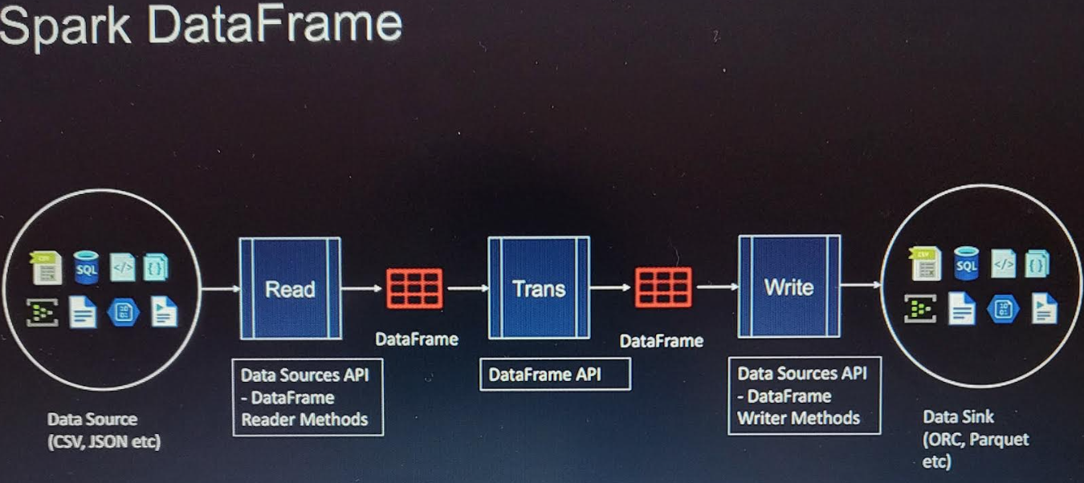

Input
Data model (To the relationship between Entities)
input data in csv and Json files

Step 1 : Dowload files and load its into ADL

Step 2 : convert csv to Parquet file (with some transformation before)
- Create a Cluster cluster1 , and start it
- Go to workspace and create new folder ----> Ingestion Folder
- In Ingestion Folder create a Nootbook called ingest_csvFile1 WITH Python a default language, choose a cluster exp : cluster1
- You can use %md maggic command to ducument you code
- MOUNT ADL and ADBricks (if needed mount and umount commands)
- Read the csv using spark Reader API as a DataFram req1

Step 3 :Train data according to requirements

Requirment1 : read Data using dataFrame

circuits_df = spark.read.csv("/mnt/stgaccountdeomdev/raw/circuits.csv") ---- display(circuits_df)
circuits_df = spark.read.option("Header","true").csv("/mnt/stgaccountdeomdev/raw/circuits.csv") ----With header
circuits_df.Show or display(circuits_df)

Requirment2 : Check , create and adapt the schema (Simple and multi-line Json )
df.printSchema(circuits_df) | to check the schema
circuits_df.discribe().Shwo() | Will show meta of file with Min and Max values
circuits_df =  circuits_df = spark.read\  .option("Header","true")\  .option("inferSchema", "true")\  .csv("/mnt/stgaccountdeomdev/raw/circuits.csv") | Adapt the schema like it was in the source system  When files a mounted you don’t neet to dbfs at the beginnin of the path

Or
You can difine first you schema Simple of Json simple or muli line structure and create you dataFrame accordingly
from pyspark.sql.types import StructType,StructField,IntegerType,StringType,DoubleType | Call the From Import methode with you needed dataTypes
circuits_Schema =  #Defintion schema  circuits_Schema = StructType() # Created a StructType object  circuits_Schema.add('circuitId',"integer",True) , # Adding col1  circuits_Schema.add("circuitRef","string",True) , # Adding col2  circuits_Schema.add("name","string" ,True) , # Adding col3  circuits_Schema.add("location","string" ,True) , # Adding col4  circuits_Schema.add("country","string" ,True) , # Adding col5  circuits_Schema.add("lat","double" ,True) , # Adding column  circuits_Schema.add("lng","double" ,True) , # Adding col7  circuits_Schema.add("alt","integer" ,True) , # Adding Col8  circuits_Schema.add("url","string" ,True) , | Example schema definition
circuits_df =  spark.read \  .option("Hearder",true)\  .schema (circuits.Schema).csv(dbfs:/mnt/formula1/raw/circuits.csv) | Use the new created schema to read you DataFrame

Requirment3 : Need colums only , remane columns
circuits_Select_df =  circuits_df.select(circuits_df.circuitId, circuits_df.circuitRef,circuits_df.name,circuits_df.location, circuits_df.country,circuits_df.lat ,circuits_df.lng, circuits_df.alt ) | Select only needed colums option1
race_Remaned_df =race_Select_df.withColumnRenamed("raceId", "race_Id")\  .withColumnRenamed("year","race_year")\  .withColumnRenamed("lat","latitude")\  .withColumn("ingestion_date",current_timestamp()) \  .withColumn("race_timestamp", to_timestamp(concat(race_Select_df.date,lit(' '),race_Select_df.time),'yyyy-MM-dd HH:mm:ss')) | Select only needed colums option2
circuits_Select_df =  circuits_df.select(circuits_df.["CircuitId"]  , circuits_df.["Circuitref"],circuits_df.["lat"])) | Select only needed colums option3
From Spark.sql.Types import col  circuits_Select_df =  circuits_df.select(col ("CircuitId"), col("Circuitref"),col.("lat")) | Select only needed colums option4
From Spark.sql.Types import col  circuits_Select_df =  circuits_df.select(col("CircuitId").alias("Circuit_Id")  ,col("Circuitref").alias("Circuit_ref"),col.("lat")) | Changing colum name
circuits_Remaned_df =  =circuits_Select_df.withColumnRenamed("CircuitId", "Circuit_Id")\  .withColumnRenamed("Circuitref","Circuit_ref")\  .withColumnRenamed("lat","latitude")\  .withColumnRenamed("lng","Longitude")\  .withColumnRenamed("alt","altitude") | Changing colum name option2

Requirment4 : add audit colum
From Spark.sql.functions import current_timestamp  circuits_final_df =  circuits_Remaned_df.withColumn("ingestion_date",current_timestamp()) | Adding an audit colums ingestion date
From Spark.sql.function import current_Timestamp , lit  circuits_final_df =  circuits_final_df = circuits_Remaned_df.withColumn("ingestion_date",current_timestamp())\  .withColumn("env",lit("Production")) | Adding an audit colums ingestion date and another columns without a pre-defined function like TimesTamp

Requirment5 : Write data as Parquet file in ADL as parquet file
circuits_final_df  .write.mode("overwrite")  .parquet("/mnt/formula1/processed/circuits")  race_Remaned_df\  .write.mode("overwrite")\  .partitionBy("race_year")\  .parquet("/mnt/stgaccountdeomdev/processed/races") | Write data as parquet file  Using patition by Year
df = spark.read.parquet(dbfs:/mnt/formula1/processed/circuits)  display(df) | Read and display the new file

Requirment6 : Partition data based on year, month or Date
The idea is to split you data in different folder when you receive lof of data by day, or per Month, or year
Note : when you don’t receive lot of data by day, it will more interresting to partition by Month , or by Year.

circuits_final_df.write
.mode("overwrite")
.PartitionBy('race_year')
.parquet("/mnt/formula1/processed/circuits")

Requirment7 : Read and write Json files(without nested structure) as parquet
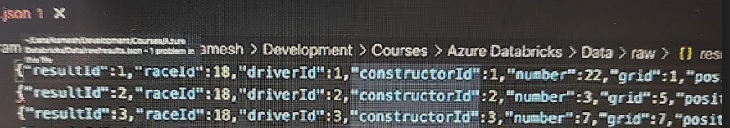
- Create a new Notebook
- Schema :Constructor.Schema = "ConstructorID INT , ConstructorRef String , name String"
- Read Json file
Constructor_df =
spark.read.schema(Constructor_Schema)\
json('/mnt/formula1/raw/Constructor.json')

- Drop colums if not needed df = Constructor_df.drop('url')
- Rename and add audit colums
- Write as Parquet file

Requirment8 : Read and write Json files(with nested structure) as parquet
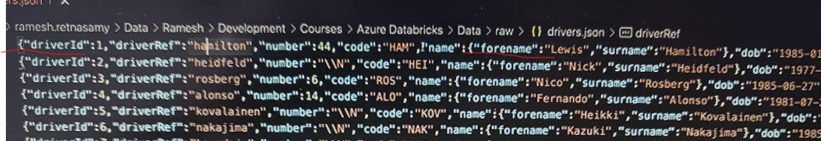
- Define 2 schema (If you have 2 Json objects in de file …)
Drivers_SchemaForName = StructureType (fields = [StructureField ("ForName",StringType(),true)])
Drivers_Schema = StructureType (fields = [StructureField("Driversld",INT ,true),
StructureField ("DriversRef",StringType(),true)
StructureField ("name",Drivers_SchemaForName) ]
)

- Concatination colmun, add and concatinate columns
From Spark.sql.Types import col,concat, current_Timestamp , lit

Drivers_concatName_df = Drivers_df
.withColumnRenamed('Driversld', 'Drivers_Id') \
.withColumnRenamed('DriversRef', 'Drivers_Ref') \
.withColumns("ingestion_date",current_Timestamp()\
.withColumns("name",concat (col("name.ForName"),lit(" ")',col("name.sURName")))

- Write the output as parquet file

Requirment9 : Read and write Json files(with Other nested structure) as parquet
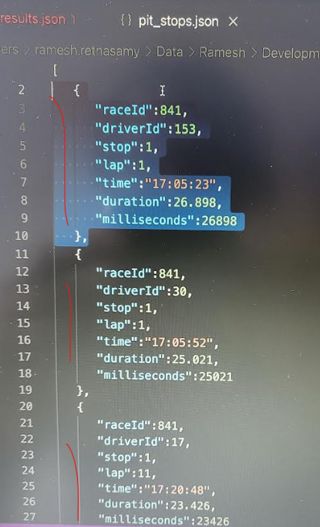

To deel with this kind of file

PitStops_df =
spark.read \
.option("Hearder",true)\
.schema (PitStops_Schema)
.option("Multiline", True)\ ----Dealing with multi line Json
.json("/mnt/formula1/raw/PitStops.Json")

PitStops_df\
.write.mode("overwrite")\
.PartitionBy('id')\
.parquet("/mnt/formula1/processed/PitStops")

Requirment10 : Read and write multiple csv files(In a folder) as parquet
Lap_Time_df =
spark.read \
.option("Hearder",true)\
.schema (Lap_Time_Schema)
.csv("/mnt/formula1/raw/Lap_Time/)
Lap_Time_df \
.write.mode("overwrite")\
.PartitionBy('id')\
.parquet("/mnt/formula1/processed/ Lap_Time ")

Note : The best practice is to create 1 folder called Ingestion and in there create 1 Notebook per file (To be ingested) , training of data can be similary done like we see before. So will do the same for :
- Circuits file
- Race file
- Construtor fils
- Drivers file
- Result file
- Pitspots
- Lap_Time
- Qualifiying

Requirment10 : Read multiple csv file to a parquet file

Child NoteBook : To make some codes reusable (Config)
Create a Folder called for example Include ------ From there
- Create 1 notebook (called Configuration)
- Create 2 variables like (In de noteBook Configuration)
raw_Folder_Path = /mnt/formula1/raw/
Processed_Folder_Path = /mnt/formula1/Processed/
- Invoke the configuration in others note books

%run "../include/Configuartion" go to folder include from for Ingestion and get Configuration info
raw_Folder_Path --- To verify the value

- Replace raw path with the variale in all ingestion file (see example)
Constructor_df =
spark.read.schema(Constructor_Schema)\
json(f"{raw_Folder_Path}/Constructor.json')

PitStops_Final_df =PitStops_df\
.write.mode("overwrite")\
.PartitionBy('id')\
.parquet(f"{processed_Folder_Path}/processed/PitStops")

Note : This need to be done to all NoteBook in the ingestion folder

Child NoteBook : Function in Notebook
Idea is to create an audit colums one time and reuse it , every that will be needed
- Create a Notebook (Common_Functions) in Include folder
From Spark.sql.function import current_Timestamp
def add_ingestion_Date (input_df)
output_df = input_df.withColums("ingestion_Date",current_TimesTamp())
return output_df

Replace in the other Notebook
%run "../include/Function"
circuits_final_df = add_ingestion_Date (circuits_Remaned_df)

Note : This need to be done to all NoteBook in the ingestion folder

Child NoteBook :Parameter in Notebook
The idea here is to Run 1 notebook that use 2 different Datasource (DataSource will be the Parameter is thsi case) , insetad of running 2 notebook with those 2 DataSources
- Create 1 Parameter and 1 varibale to store the Datasource as a new colums
dbutiLs.widgets.text("p_dataSource","")
v_dataSource = dbutiLs.widgets.get("p_dataSource")

- Add that to all Notebook to have a column dataSource
From Spark.sql.function import lit
Drivers_concatName_df = Drivers_df.withColumnRenamed('Driversld', 'Drivers_Id') \
.withColumnRenamed('DriversRef', 'Drivers_Ref') \
.withColumns("ingestion_date",current_Timestamp()\
.withColumns("name",concat (col("name.ForName"),lit(" ")',col("name.sURName")))
.withColumns("dataSource",lit( v_dataSource))

Notebook workflow (Mater NoteBook)
Create a kind of master notebook that will execute all ingestion notebooks and return a status of Succeeded or failiure
- Create a new notebook in de folder (Ingest_all_files)
In noteBook1 add the following code a the end : dbutiLs.notebook.exit("Succeeded ")
v_result = dbutiLs.notebook.run("notebook1",0,{"p_dataSource":"Ergast_API"}) -- run Notebook 1
v_result --- check the Status : Succeeded or failure
- In the Ingest_all_files notebook repeat the above step for all the other notbooks

DataBricks Job
(Section 12.9)
You will need a job to run all the notebook in one shot (or Schedule the run) , with parameter specification ect

FILTER in Notebook
Df = Constructor_df.filter("age" > 20)
Df2 = Constructor_df.filter((Constructor_df.filter.["age"] == 20) & (Constructor_df.filter.["Round"]> 5) )

JOIN IN Notebook

INNER JOIN
Join_df = df1.join(df2, df1.name == df2.name, 'INNER')
Join_df2 = df1.join(df2, df1.name == df2.name, 'INNER')\
.Select(df1.name, df1.Adress,df2.city)

OUTER JOIN
Join_df3= df1.join(df2, df.name == df2.name, 'left')
Join_df3= df1.join(df2, df.name == df2.name, 'Right')
Join_df3= df1.join(df2, df.name == df2.name, ‘full’)
Join_df3= df1.CrossJoin(df2) Cartisian produit of both table

SEMI JOIN
Join_df3= df1.join(df2, df.name == df2.name, 'semi') -- Will give you only the columns of first table
Join_df3= df1.join(df2, df.name == df2.name, 'left semi') -- Will give you only the columns of first table

ANTI JOIN
Join_df3= df1.join(df2, df.name == df2.name, ANTI) -- Will give not matched value

ORDER BY
dF = Constructor_df.filter("age" > 20).orderby.Age.desc()

Create a Presentation Layer (for the joins)
Beste practice is to create in ADL near the Raw , processed folder a presentation layer. This you can mush more manage the access to those data . You will not want to give access to the raw folder to an presenattion API like PowerBI.

- Create a Folder Presentation in ADL
- In Dbriks Mount this folder using the set up and configuration notebooks
- Create new folder near Insgetion called Trans
- Create a new Notbook (In trans) called Race_result
- Create dataFrame to read all needed file from processed folder
  - Prefrom need transformations (Rename)
- Apply join transfomation to get all the new dataFrames togever
  - Select only needed columns
  - Regarding the data model before, apply the join to get all info required
- Write the final dataFrame to the Presentation folder as a Parquet file

AGGREGATION

Count
From Spark.sql.function import count
df1=Constructor_df.Select(count("*"))
df1=Constructor_df.Select(count("*")).Show
df1=Constructor_df.Select(count("ConstructorName"))
df1=Constructor_df.Select(countDistinct("ConstructorName"))

Sum
df1=Constructor_df.Select(sum("points"))
df1=Constructor_df.filter("age"== 20).(Select(sum("points"))
df1=Constructor_df.filter("year"== 2020).(Select(sum("points"), countDistinct("ConstructorName") )

Group BY
df1=Constructor_df.GroupBy("year").sum("points")
Multiple aggegation in 1
df1=Constructor_df.GroupBy("year")\
.agg.(sum("points"),countDistinct("ConstructorName") )

df1=Constructor_df.GroupBy("year")\
.agg.(sum("points").alias("TotalPoints"),countDistinct("ConstructorName").alias("ConstructorName")

Df2=Constructor_df.GroupBy("year" , "name" )\
.agg.(sum("points").alias("TotalPoints"),countDistinct("ConstructorName").alias("ConstructorName")

df1=Constructor_df.GroupBy("year")\
.agg.(sum("points").alias()"TotalPoints",
when(col("Position" ==1 ,True).alias("Win")

Window function
From Spark.sql.window import window
From Spark.sql.function import desc ,rank
Win_Df =window.PartionBy("year").OrderBy(desc("TotalPoints"))
Df = withColumn("Rank"),rank().Over(Win_Df)

Note : In the same way you create in Trans folder a new NoteBook (Standing), and do all needed transformation en put the output into a parquet file

SQL with SPARK

Create Local temp view and access with SQL
Only available in a guiven session
SQl_temV_Df =
df1.createTempView("V_Result")
SQl_temV_Df = df1.createOrReplaceTempView("V_Result")

%sql
Selec * from V_Result
Spark.sql("Selec * from V_Result where age =10")

Create Global temp view and access with SQL
Available for all notebook in a given Databricks
SQl_temV_Df = df1.createOrReplaceGlobalTempView("gV_Result")

%sql
Selec * from global_Temp.gV_Result
Spark.sql("Selec * from global_Temp.gV_Result where age =10")

SQL DATABASE IN DATABRICKS
Create Database if not exists demo
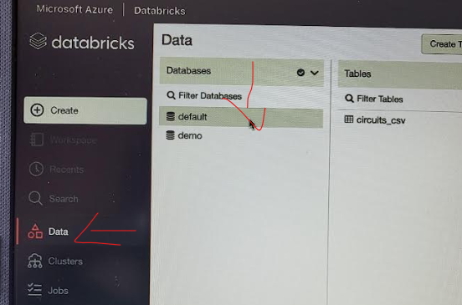

Show.databases
DESCRIBE DATABASE demo ,
DESCRIBE DATABASE EXTENDED demo ,
SELECT CURRENT_DATABASE()

Use demo,
SHOW TABLES ,

MANAGED TABLES

%Python
Constructor_df = spark.read.Parquet.
(f"{raw_Folder_Path}Constructor.json")

%Python
PitStops_Final_df =Constructor_df\
.write.format("parquet")\
.SaveAsTable(demo.Race_result_Python)

Use demo,
SHOW TABLES ,
DESCRIBE DATABASE EXTENDED demo ,

%sql
Use demo
Create table Race_result_sql
AS
Select * FROM demo.Race_result_Python
WHERE YEAR = 2010

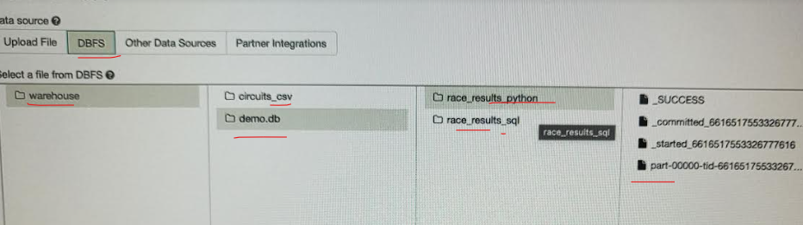
Drop table demo.Race_result_sql

EXTERNAL TABLES
%Python
PitStops_Final_df =Constructor_df.write.format("parquet")\
.Option("path", (f"{presentation_Folder_Path}/Race_Ext_result_Python")")
.SaveAsTable(demo.Race_Ext_result_Python)

DESCRIBE EXTENDED demo. Race_Ext_result_Python

%sql
Use demo
Create table Race_result_sql
(
id int,
name string,
age int
)
uning parquet
LOCATION :/mnt/formula1/Presentation/Race_result_sql

Insert into Race_result_sql
Select * from demo.Race_Ext_result_Python

VIEWS

Temp view
Create Or Replace temp view v_tab1
AS
SELECT * From demo.Race_Ext_result_Python

Global view
Create Or Replace Global temp view gv_tab1
AS
SELECT * From demo.Race_Ext_result_Python

Perment view
Create Or Replace view pv_tab1
AS
SELECT * From demo.Race_Ext_result_Python

Note :
Termp view mostly beeing in a current DB session in 1 note book
Global view mostly beeing used in multiple notebooks
Permanent Views mostly beeing use to connect to dashboard, reports….

PROJECT including tables and views
(Section 16)
- Create 3 Databases in new notebook (Raw tables)
  - Raw
  - Process
  - Presentation
- Create coresponding External tables based on schema and files in each DB
  - Cvs based External table
  - Json based External table
- Join tabes to get 1 data source for reporting

VISUALIZATION
Use visualyzation insite the notebook
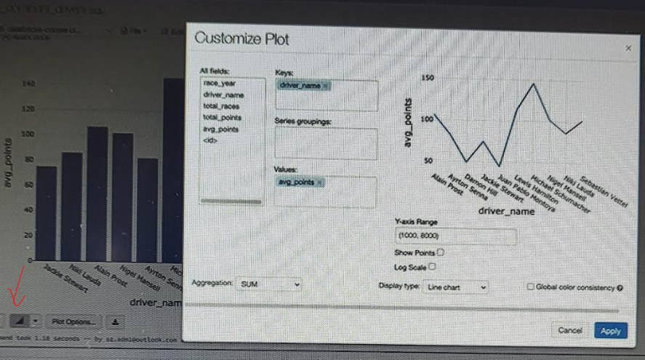

DASHBOARD
The created vizualization in the nootbooks can be using in a Dashbord.

- Use
To organise the the style of the dashboad do the folowings :
%Python
html = """<H1 Style....> .............<H1/>"
displayHTML(html)
- Choose view -- Dashbord - add new Dashbord
(Section 18 .105)
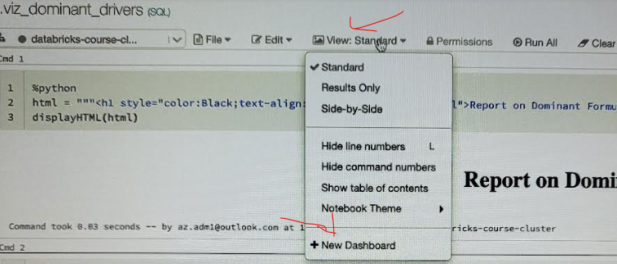

Encremental laod
We want to laod data from de raw folder to the Precessed and presentation tables incrementally
- Drop and Re-create the Database and it tables
Drop DATABASE IF EXISTS F1_Processed CASCADE
CREATE DATABASE IF NOT EXISTS F1_Processed
LOCATION :"/mnt/formula1/Processed"

Drop DATABASE IF EXISTS F1_Presentation CASCADE
CREATE DATABASE IF NOT EXISTS F1_Presentation
LOCATION :"/mnt/formula1/Presentation"

- Create a Parameter for the file_date (Name of folder containing files)
- Add the new Parameter when reading de file
.csv(f"{raw_Folder_Path}/v_file_date/circuits.csv") -- folde name is v_file_date
- Add new column for folder name
.withColumns("file_date",lit(v_file_date))
Note do the same all file like circuits
- Load incremental
circuits_final_df.write.mode("append").PartitionBy('race_id').SaveAsTable(f1_processed.result) - This will not suffisant because it will append new data and some partition will be duplicate

To solve this issue

Spark.Config.Set("Spark.sql.Source.partitionOverWriteMode","dynamic")
---will find de existing Partition that are coming again

Results_Finals_df = Results_Finals_df.Select (.......,...,....,,.,"raceId")
---- Make sure the goed order of columns

If (spark._jSession.Catalog.Tables.exists("f1_processed.result"))
f1_processed.result.write.mode("overwrite").insertInto(f1_processed.result) - overwrite existin P
Else
circuits_final_df.write.mode("append").PartitionBy('race_id').SaveAsTable(f1_processed.result)

Note repeat the steps for all other files (Using funcion Section 19.115 )

DELTA LAKE
https://docs.delta.io/latest/index.html documentation
(Secton 20)
Delta Lake is like a DataLake but with ACID transation control

Create , Read and write Data into Delta Lake
Process
- Create a container in ADL
- Mount This new container with ADBr
- Write data to Deta lake
  - Create new DB demo
  - Create a DataFrame using Spak.read….
  - Write this df as Delta table (or to folder)

Result_df.write.format("delta").mode("overwrite").saveASTabel("f1_demo.Result_managed")
Result_df.write.format("delta").mode("overwrite").savel("/mnt /formul1 /demo /results_External")

Load delta to Dataframe
dF1 = spark.read.format("delta").load("/mnt /formul1 /demo /results_External ")

Result_df.write.format("delta").mode("overwrite")
.PartitionBy("RaceId")\
.saveASTabel("f1_demo.Result_Partition_managed")

Update Delete the Della Lake
Data Lake do not support Delete and Update but Delta Lake support those

- Update
%sql
Update like in SQL …..

%Python
From Spark.sql.function import DeltaTable
deltaTable = DeltaTable.ForPath(Spark,"/mnt /formul1 /demo /results_External")
deltaTable.Update("Position > 10" ,{"point" :"11-Position" })

- Delete
%sql
Delete from ……Like in sql

%Python
From Spark.sql.function import DeltaTable
deltaTable = DeltaTable.ForPath(Spark,"/mnt /formul1 /demo /results_External")
deltaTable.delete("Position > 10" )

Merge and upsert
(Section 20 . 125)
With Deta table you can merge using usert
In SQL en Also in Python

History , Time Travel , Vacuum

- History

%sql
DESC HISTORY detaTableName
SELECT * FROM deltaTableName VERSION AS OF 1
%Python
To search ….

- Time Travel

%sql
SELECT * FROM deltaTableName TimeStamp "YourTimeStamp"
%Python
To search ….

- Vaccum
Remove historical data old than 7 days
This will remove that older dan 1 day

SET Spark.DataBriks.delta.RetentionDurationCheck.Enable ="False"
Vaccum DetaTableName RETAIN 24 HOURS

- Roll back to Presviouis version , when you accidentally delete row in a Delta Table,
By using Merge between last version en niew version of data

Transaction log
When you create a Delta tabale , a Transaction Log folder (Contain a Json file with log info) is automatically created. A parquet file is also created that will contain the historical values.

Convert Parquet to Delta lake and back to Parquet file

- Parque to Delta
%sql
CONVERT TO DELTA "YourParquetTable"

- Delta to Parquet
Read a DetaTable in a DataFrame and write it back as a Parquet file

EXERCICES USING DELTA TABALE
(Section 20 .129 -135)

DATA FACTORY
Will be use to run the created Notebooks
(Section 21 .140 – 145)

Connect Power BI to DataBricks
(Section 22)
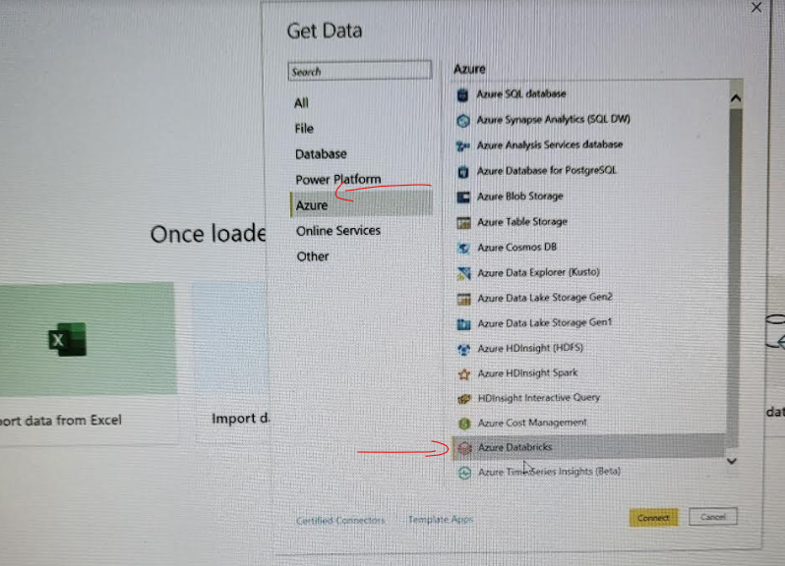

Devops for the deployment
https://www.youtube.com/watch?v=R7tJZelEt-Q&t=28s

Some code

Using ADL

Needs :
Storage account
Databriks Workspace | With a Runing cluster
Active directory - Service principal | URI, Tenant Id , Secret
KeyVaut | To hide the URI, Tenant Id, Secret
All those 3 should be inter connectted

def mount_adls(container_name):  dbutils.fs.mount(  source = f"abfss://{container_name}@{storage_account_name}.dfs.core.windows.net/",  mount_point = f"/mnt/{storage_account_name}/{container_name}",  extra_configs = configs)  ---------------------------------------------------  mount_adls("raw")  mount_adls("processed") | Funtion to amount ADL folders  --------------------------------------------------  Function execution to amount folders raw and processed
dbutils.secrets.listScopes() | List fo all secret scopes
dbutils.secrets.list("Formula1-scope")  ----------------------------------------------------------  Result  [SecretMetadata(key='databricks-app-clientId'), SecretMetadata(key='Databricks-app-Secret'), SecretMetadata(key='databricks-app-tenantId')]  -----------------------------------------------------------------------  Configuration will look like  storage_account_name = "stgproazureoc"  client_id = dbutils.secrets.get(scope ="Formula1-scope",key="databricks-app-clientId")  tenant_id = dbutils.secrets.get(scope ="Formula1-scope",key="databricks-app-tenantId")  client_secret = dbutils.secrets.get(scope ="Formula1-scope",key="Databricks-app-Secret") | Secret scope : Formula1-scope  When you use Keyvaut , this are KeyVault value you will be set-up your notebooks configuration
dbutils.fs.ls("/mnt/stgproazureoc/raw") | Show the amounted folder

Full Config set up
You will need to add this to databrics url /secrets/createScope
Key Values
storage_account_name = "stgproazureoc"
client_id = dbutils.secrets.get(scope ="Formula1-scope",key="databricks-app-clientId")
tenant_id = dbutils.secrets.get(scope ="Formula1-scope",key="databricks-app-tenantId")
client_secret = dbutils.secrets.get(scope ="Formula1-scope",key="Databricks-app-Secret")

General settings

configs = {"fs.azure.account.auth.type": "OAuth",
"fs.azure.account.oauth.provider.type": "org.apache.hadoop.fs.azurebfs.oauth2.ClientCredsTokenProvider",
"fs.azure.account.oauth2.client.id": f"{client_id}",
"fs.azure.account.oauth2.client.secret": f"{client_secret}",
"fs.azure.account.oauth2.client.endpoint": f"https://login.microsoftonline.com/{tenant_id}/oauth2/token"}
Fubction

def mount_adls(container_name):
dbutils.fs.mount(
source = f"abfss://{container_name}@{storage_account_name}.dfs.core.windows.net/",
mount_point = f"/mnt/{storage_account_name}/{container_name}",
extra_configs = configs)
Mount point1
Fma
Mount point12
dbutils.fs.unmount(“/mnt/Formula1/processed”)
mount_adls("processed")
dbutils.fs.ls("/mnt/stgaccountdeomdev/raw") to check result
display(dbutils.fs.mounts()) to check result
%fs
ls /mnt/stgaccountdeomdev/raw to check file in a folder
circuits_df.printSchema() to check schama of the Data-farme
circuits_df.describe().show() to give description of the Data-farme

Using DATABASE
When you register the data ADL (file) in hive metastore spark will treat its then like Database objects like
- Table
- views
Spark SQL access the File in ADL as Table or view using the meta data store in the Hive metastore
Databriks can also have Databases witch have :
- Table
  - Managed tables (fully control by Db)
  - External table ( notfully control by Db)
- Views (From tables)
Nb:
creating a table will create also a file in ADL (in the given path)
dropping a manage table will also drop the corresponding file in ADL, dropping de External file still maintain the corresponding file in ADL.

Some error handeling

Issue | Explanation | Solution
- IP adress limit  - Quota increasing needed | When you have a free account | Free up the resources from the Rg, stop inactive Cluster.  Use a single node instead of multi
Mount This request is not authorized to perform this operation using this permission.&#34 | Service principal not good set , in ADL | Make sure the service principal is good set
IndentationError: expected an indented block | This is a space error | Check spaces

